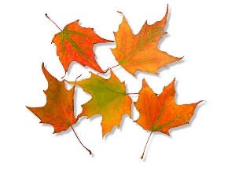
John E. Ford PTA 2016
Fall Festival Pre-order Form
(Preorder by 10/12/16)

Student Name: _________________________________________________

Teacher Name: _________________________________________________

Parent Email: ____________________________________________________

Quantity:

Admission Armbands @ $5 each

Food or Drink tickets @ $1 each (All food and drinks cost $1 - $3)

Horse/Pony, Train Ride, or Hamster Wheel @ $2 each

Game Truck @ $2 (unlimited play)

Total amount enclosed $_____________

Note: This is a FAMILY event 10/14/16 from 3:30pm to 6:30pm. Students may not attend without a parent/adult supervision. Adults may not attend without a child.
Also note: Admission for adults is free and admission for children includes unlimited games, crafts and inflatables. Credit card/debit card payments can be taken only at the event.

